Shape C is a parallelogram with a base of 2 and a height of 3.
Can you use the two pictures below to work out the area of the parallelogram?
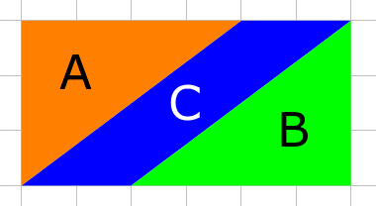 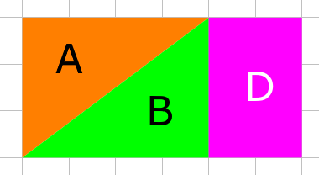
Here are two more parallelograms made by shearing a rectangle with a base of 2 and a height of 3.
Can you draw similar diagrams to work out their areas?
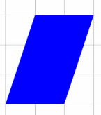 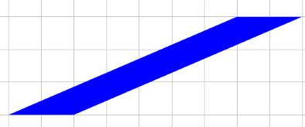
Draw some more parallelograms with a base of 2 and a height of 3.
What do you notice? Can you explain it?
Explore other families of parallelograms with a particular base and height.
Can you come up with a general rule for working out the area of a parallelogram if you know its base and height? Can you explain why your rule works?
I wonder what happens when we shear triangles...
Here is a family of four sheared triangles with a base of 1 and a height of 2.
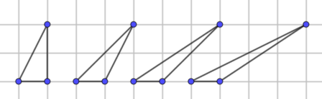
Can you work out the area of the triangles?
Explore other families of triangles with a particular base and height.
Can you come up with a general rule for working out the area of a triangle if you know its base and height?

